
Computer Networks Lab_241L
UW-24-CS-BS-101
Registration NO:
Muhammad Talha_CS.3ndB
Lab Task # 03
UNIVERSITY OF WAH(UOW)

DEPARTMENT OF COMPUTER
SCIENCE

COURSE:

SUBMITTED TO:

Mr. Hassan Shafaqat
SUBMITTED BY:

Task
- Adding Computers
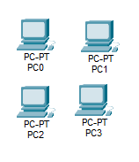
- Adding Switches and hubs
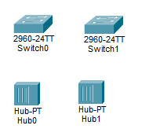
- Arranging in sequence
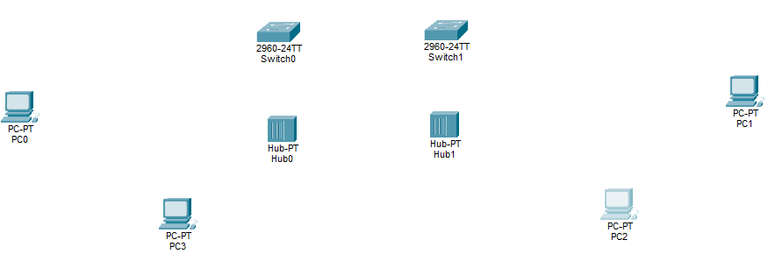
- Attaching wires
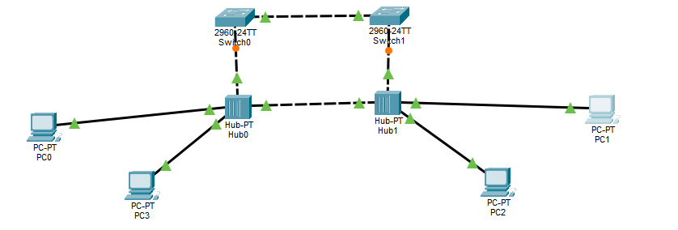
- Giving IP address
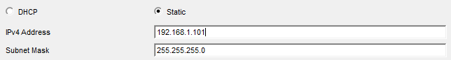
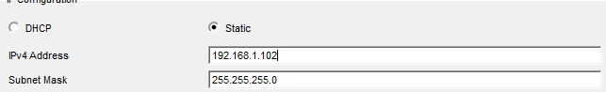
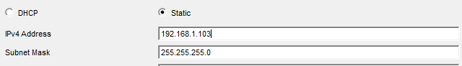
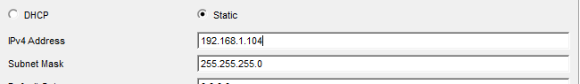
- Sending Messages
From PC 1 to ALL
From PC 2 to ALL
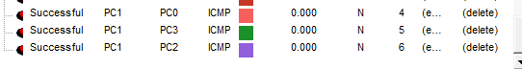
From PC 3 to ALL
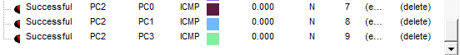
From PC 4 to ALL
